 | SATW Themenplatform TPF « e-switzerland »  Projet P8/9  Study Day  on Some new innovative approaches of the patent problematics | 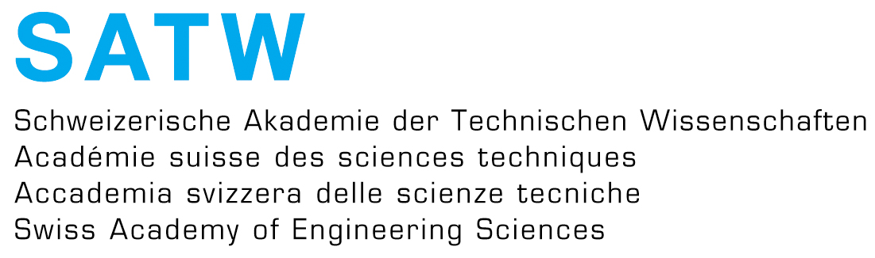

Genève , le 4 juin 2012

Draft 4

STUDAY DAY at EHL in Lausanne
Organised by SATW TPF e-switzerland
One day in 4thQ 2012 (to be fix)

Some new innovative approaches
of the patent problematics

based on preliminary works of Thematic N°8 and N° 9 of the SATW platform e-switzerland :
Theme 8 : Typologie et indexation des brevets par densités de revendications selon le classement PCT & OMPI
Theme 9 : Patent comparaison and business impacts

Context :
It is well described in the two above mentionned website, with namely these 2 documents
http://www.ict-21.ch/com-ict/IMG/doc/Abstract4-16042012-synthesis.doc
http://www.ict-21.ch/l4d/mod/file/download.php?file_guid=345170

Objectives :

- To present the existing reflexions
- To share views on the topics of this Study Day
- To illustrate through demonstrators the innovative ways to tackle with the implied problematics of patent with all the components (law,economy,innovation,…)
- To elaborate next steps for the research taking in account the real needs of users and innovators
- To initiate some new projects as hybrid solutions.

Links with SATW missions and foresight processes in e-switzerland :
Cf paragraphs 2-4 in the 2 following documents
http://www.ict-21.ch/com-ict/IMG/doc/Abstract4-16042012-synthesis.doc
http://www.ict-21.ch/l4d/mod/file/download.php?file_guid=345170

Outputs :

- The powerpoint presentations for the participants
- The emerging projects after the Study Day
- The networking of the concerned bodies
- A report to the SATW
- Eventually articles in some specifiec media

Draft Programme :

- 9h15 Welcome coffee at EHL
- 9h45 Introduction of the Study Day (EHL, State of the Art)
- 10h00 Presentation of the SSM system JZ (20’ + 10’ Q)
- 10h30 Demonstrators of cases around the SSS system JS (20’ + 10’ Q)
- 11h00 The patent Galaxy AW (20’ + 10’ Q)
- 11h30 First discussions
- 12h00 lunch at EHL
- 13h30 Working groups with specific targets ➔ answering a framework
- 15h00 Synthesis in plenary of the WG findings
- 15h30 Discussion in plenary
- 16h15 End of the Study Day

Budget asked to SATW : CHF 1280.-

- Travel CHF 480.-
- Lunch CHF 800.-

Targetted population :

Potential paticipants to invite
(participant limit ca 20 – Only by invitation)

JZ member of platform TPF e-switzerland and co-organiser
JS member of platform TPF e-switzerland and co-organiser
AW member of platform TPF e-switzerland and co-organiser
RM member of platform TPF e-switzerland and co-organiser
Robert STOYAN, project manager, TECFA – Uni GE
Patrick FURRER, Head office, EUResearch – Bern
Thibault ESTIER, MER, SES – UNIL University of Lausanne
Olivier GLASSEY, Professor, OSPS (Observatory Science, Politics and Society) – UNIL
Stéphane KOCH, Conseil & Formation en intelligence économique, intelligentzia.net
GianLuca MISURACA, EU, Joint Research Centre (JRC), Institute for Prospective Technological Studies. In Sevilla
A colleague of AW at EHL in marketing and innovation, France AW to act by giving the right info
Ray F. IUNIUS, Prof.and Director Institut d’innovation et d’entrepreneuriat (INTEHL) at Lausanne (AW)
A delegate of Swissmen through a next meeting of RM with Hans Hess
Andreas SCHWEIZER, director of API – Geneva
Niklaus MEYER, Fachgruppe Green IT der SI
Beat LEHMANN, Fachgruppe IT-Compliance der SI
Carsten MIEHLING, Fachgruppe Financial-IT - Standards und Prozesse der SI
Jacques GUYOT, Chargé de cours, Centre universitaire d'informatique –CUI-UNI-GE, founder of Simple Shift – language engineering
Some people of selected SATW PTFs
Gilles FALQUET, Prof. CUI Uni-GE
Farag MOUSSA, Honorary President – International Federation of Inventors’ Association (IFA)
A delegate from KTI in the new constellation of 2013 with new State Secretariat PF to update
Alicja ADAMCZAK, Patent Office in Poland, Warszawa
Ron MARCHANT, Intellectual Property, Innovatio, and Development, former head of the UK Intellectual Property Office
Some other suggestions …….
.
.
.
.

