From Celebrations of the 50th anniversary of the IFIP TC3 to … sustainable education

Summary and context
With the presentation by Raymond Morel, Swiss TC3 reps and TC3 Special consultant, on the 3rd of July 2013 at Torun WCCE’2013, we have a smart and extensive contribution to explicit the network of competences and awareness during 50 years of radiant and anticipative activities from a community of experts collaborating with plenty of bodies and not restricted to WCCE (World Conference on Computer in Education).

I have to confess that it was not easy to select and describe 50 years of activities (ca 3 cubic meters of documents), when during the same period the world moved a lot and not only reagarding the evolution of technologies (in 1971 my institution paid CHF 50‘000.- for a HP table computer with a plotter and CHF 32’000.- for a memory extension – 4k of 16 bits - of our time sharing system. Remember in 1963 EU did not exist yet (Common Market of 6 countries only) and since this time a lot iof nnovations and discoveries appeared not forgetting many changes which emerged in almost all the societies.

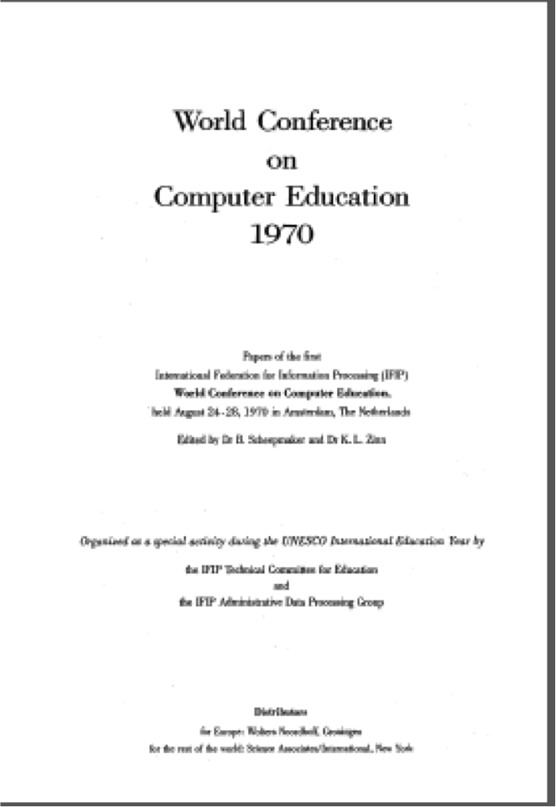 | 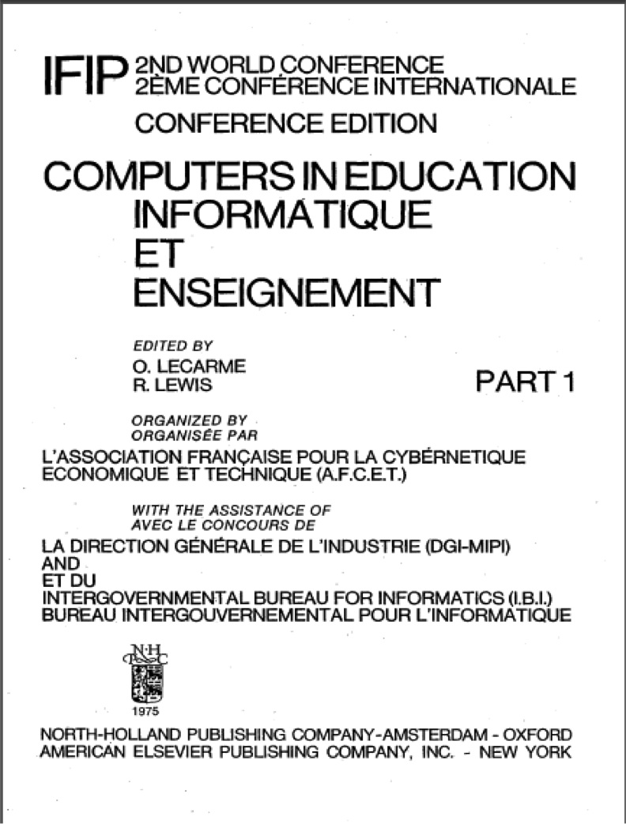 | 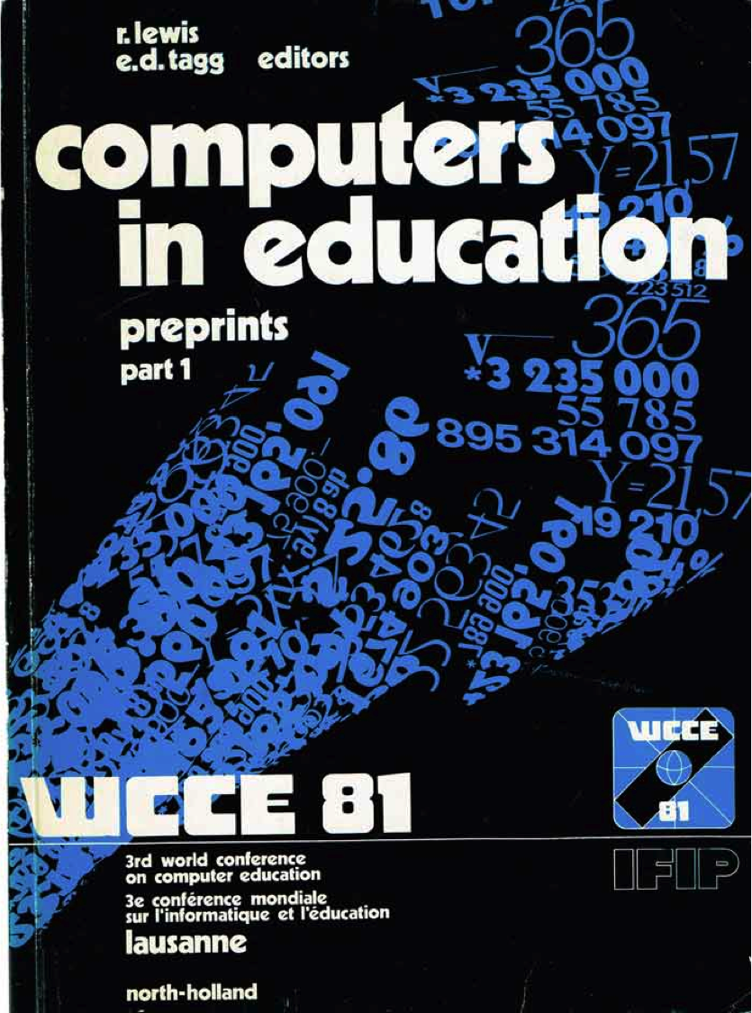 | 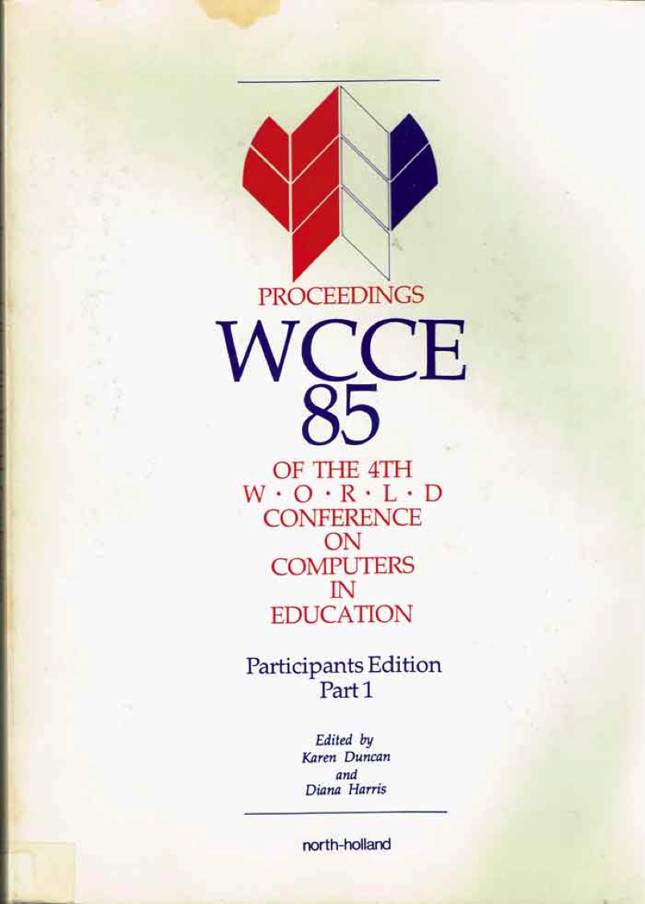 | 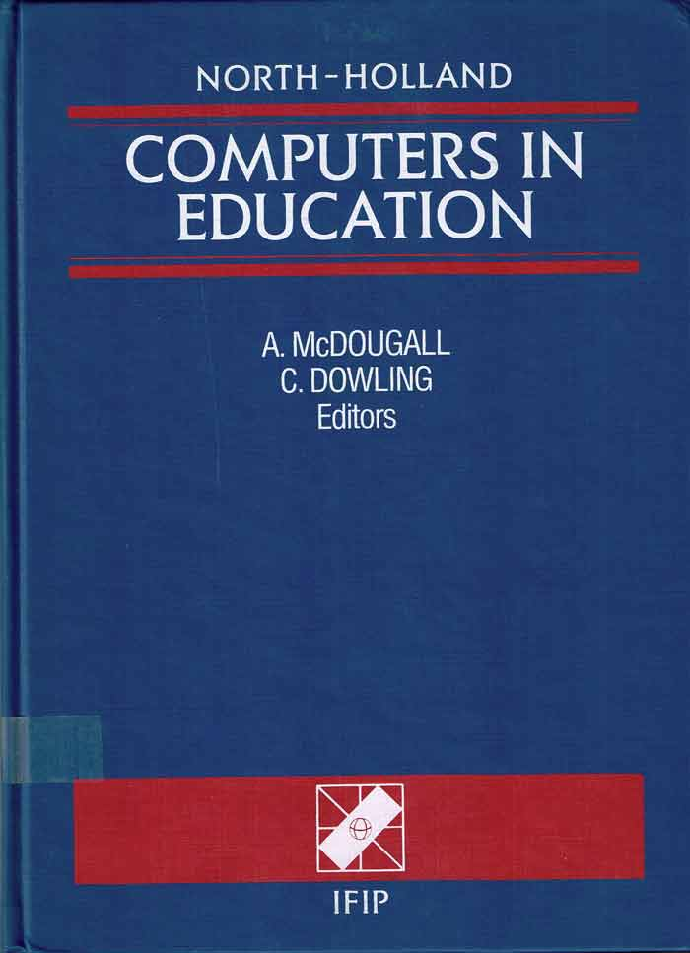
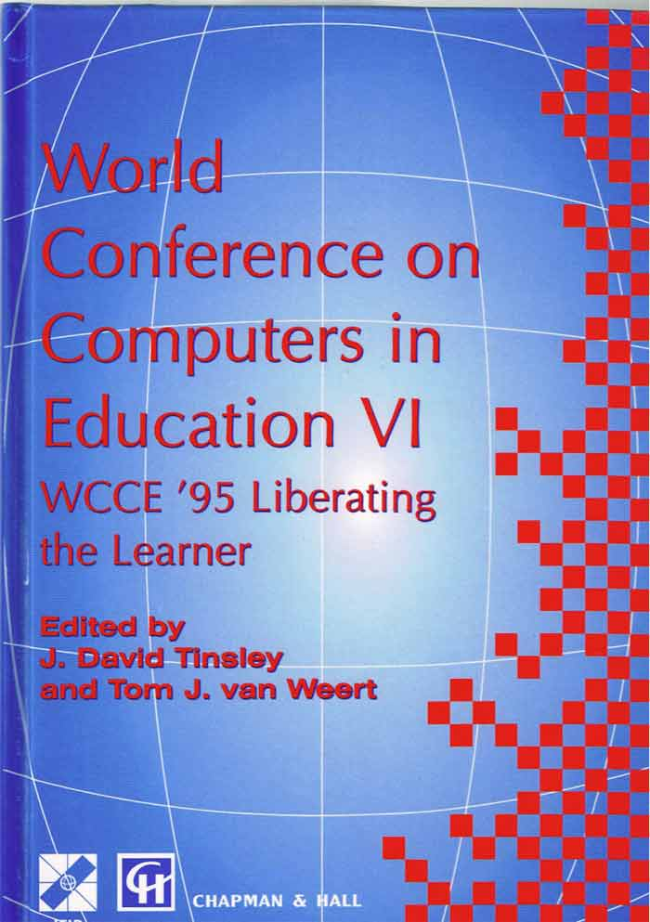 | 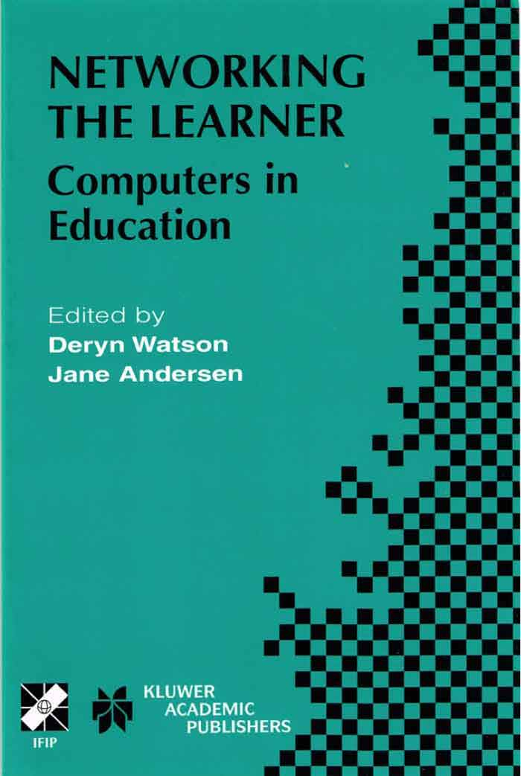 | 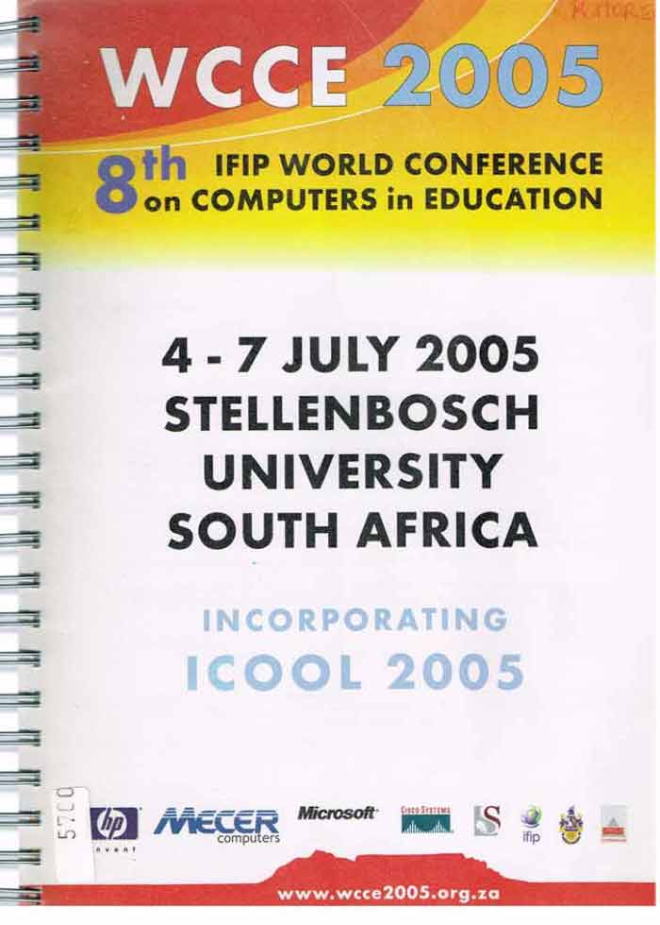 | 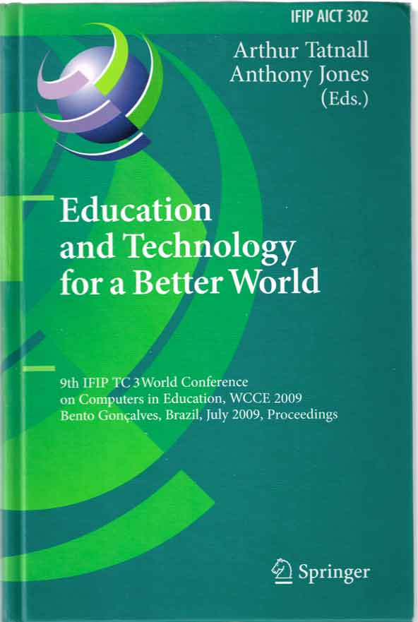 | 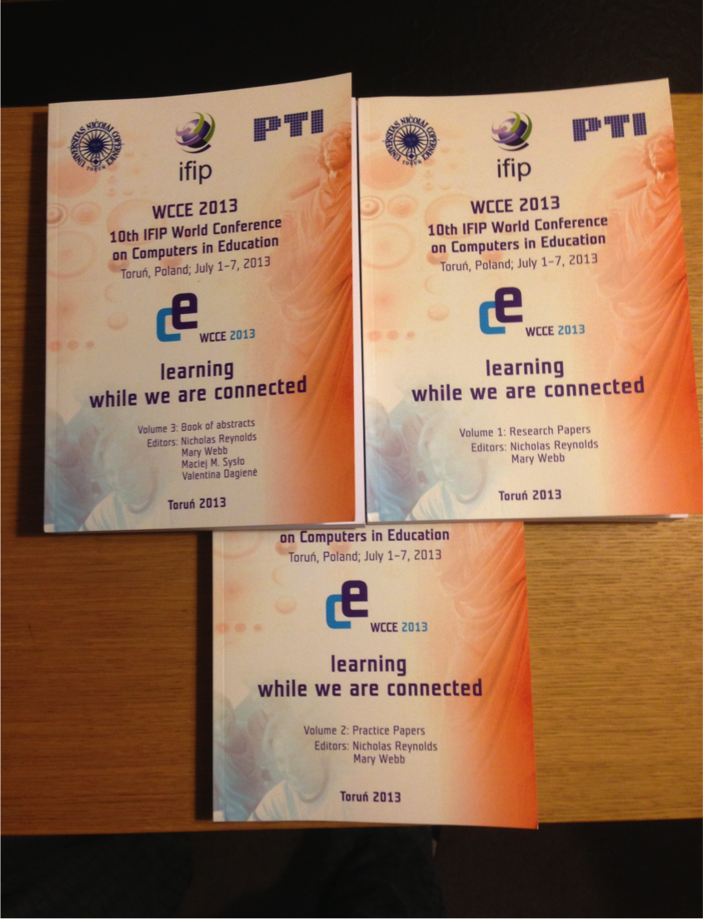

You can easily observe and identify some facts :

- the evolution of titles for each contribution over time.
- how long it takes to put an idea or a concept in action
- difficulties to express clean visions and to apply them along the time
- some findings of TC3 activities are well hidden behind a publishing process heavy and costly which prevents the quick spreading of good improvements
- some bright anticipate visions to ease decision makers
- the reactivity of educational systems which prefer some «political », local, partial and slight reforms instead of a deep re-engineering of the whole organisation
- the impression of conservatism to continue empowering the primacy of teaching in front of learning (the learner knows nothing) with its usual alibis (curriculum, diploma, teacher education, exam's, evaluation, didactic of subject areas, etc)
- the gap between the speed of development of technology and the slow integration of human behaviours
- the too fast planning of projects and sometimes the lack of valorisation from the authority side
- the non-balance between technology driven and pedagogy driven
- the impression that we move from a wrong paradigm (each learner is stupid) to an other wrong paradigm (in front of a screen each learner is clever),
- etc,…

According to the fact that neither the goals of MDG (Millenium Development Goals) neither the targets of WSIS (World Summit of the Information Society) will be reached in 1015 as promised, there is time to work harder on the TC3 problematic’s (ICT and Education), because it’s not the announcement last May during the WSIS Forum that « on the earth there are 7.x billion of inhabitants and 7.x billion of mobiles » which will solve the problems.

There still remain plenty of questions to solve :

- the answers fixing the place of education in each society to base any development with ICT including the cultural diversity ?
- what is digital pedagogy ?: to avoid to put ICT in existing education systems rather then select the appropriate attitude where ICT enriched existing pedagogies ?
- to act in a global and systemic way namely with the population of learners incorporating from the beginning the necessity of Lifelong Learning processes ?
- how to promote digital e-literate citizens ?
- how to avoid confusing prediction and prospective ?
- how to facilitate reaching sustainable education in the long time ?
- etc,…

The announced Torun vision as a concrete follow-up after a series of declarations (2002, 2003, 2005 and 2009) and should help planning for the 11th WCCE in Dublin in 2017 and in 2021 (WCCE was never held in Asia … !).

If you are interested to be involved, you have an appointment at
http://ifip-education.ning.com/

The presentation is 112 slides (ca 17Megas) including behind this « backbone » some 700 slides and 50 other links to better sitaute the worldwild TC3 actions http://www.ict-21.ch/com-ict/IMG/ppt/50th-TC3-WCCE-2013-Torun-v2013.ppt
“If we want things to stay as they are, things will have to change” ― Giuseppe Tomasi di Lampedusa, The Leopard

