**Don’t Leave Learning Up to Chance: Framing and Reflection**

**[MindShift](https://ww2.kqed.org/mindshift/)**

[Search](https://ww2.kqed.org/mindshift/2016/09/14/dont-leave-learning-up-to-chance-framing-and-reflection/#search-container)

[Skip to content](https://ww2.kqed.org/mindshift/2016/09/14/dont-leave-learning-up-to-chance-framing-and-reflection/#content)

* [MindShift Podcast](https://ww2.kqed.org/mindshift/category/mindshiftpodcast/)
* [growth mindset](https://ww2.kqed.org/mindshift/tag/growth-mindset/)
* [Teaching Strategies](https://ww2.kqed.org/mindshift/category/teaching-strategies/)
* [Big Ideas](https://ww2.kqed.org/mindshift/category/big-ideas/)
* [Games and Learning](https://ww2.kqed.org/mindshift/tag/games/)

[Teaching Strategies](https://ww2.kqed.org/mindshift/category/teaching-strategies/)

Infographic explaining the importance of reflection in maker education. (*Courtesy Jackie Gerstein/*[*User Generated Education*](https://usergeneratededucation.wordpress.com/author/jackiegerstein/))

By [Katrina Schwartz](https://ww2.kqed.org/mindshift/author/katrinaschwartz/) September 14, 2016

[Share](https://ww2.kqed.org/mindshift/2016/09/14/dont-leave-learning-up-to-chance-framing-and-reflection/)

[Jackie Gerstein](https://usergeneratededucation.wordpress.com/author/jackiegerstein/" \t "_blank) is an experienced educator who has been working as a classroom teacher and pre-service teacher trainer for years. With a background in experiential learning, Gerstein is excited about current trends in education that have more people excited to try project-based learning, maker education and other approaches that let students get hands-on with their learning.

She hopes all the excitement turns into robust, meaningful change in how mainstream teachers educate. To do that, she says it’s crucial that teachers not only focus on the materials and tools of a maker activity, but also carefully [frame it](https://usergeneratededucation.wordpress.com/2016/03/16/framing-and-frontloading-maker-activities/" \t "_blank) and [reflect upon it](https://usergeneratededucation.wordpress.com/2015/10/05/reflecting-on-the-making-process/" \t "_blank) to make sure learning happens.

“If we don’t create a process of reflecting and framing them, then we are leaving learning up to chance,” Gerstein said on a panel about makerspaces hosted at the [International Society of Technology in Education (ISTE)](https://conference.iste.org/2016/" \t "_blank) conference.

Sponsored By

To frame lessons, Gerstein thinks carefully about her goals for the lesson and then makes sure the kids are thinking about those goals, too, by asking essential questions. If the goal is to meet certain standards, the class might have a brief discussion of the standards in question, framed in kid language. Or the teacher might ask, “How would an inventor or scientist approach this problem?”

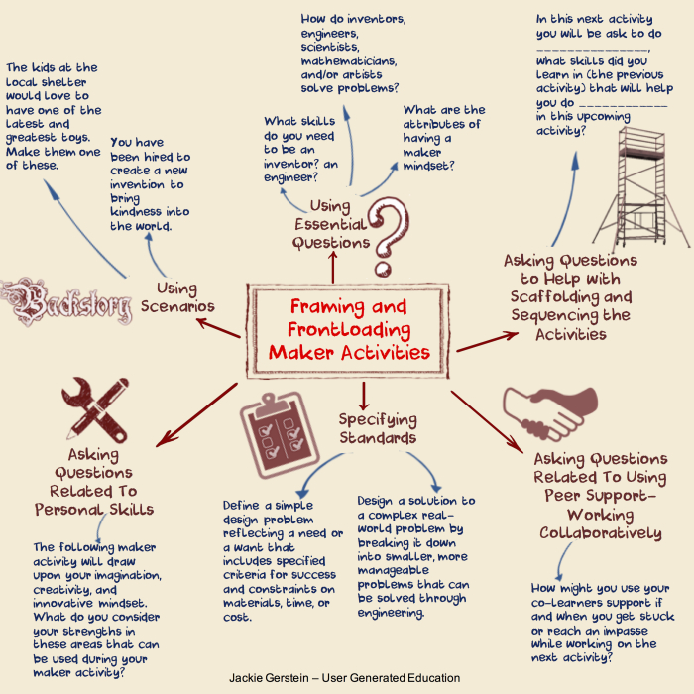Frontloading and framing are important parts of a maker activity. *(Courtesy Jackie Gerstein/*[*User Generated Education*](https://usergeneratededucation.wordpress.com/author/jackiegerstein/)*)*

“I think maker-ed has huge potential to build social emotional skills and I don’t think that’s being tapped enough,” Gerstein said. Problem-solving, managing emotions, organizing one’s time and designing with empathy are often all part of the making experience, but if teachers want to make sure students recognize they are building those skills, they need to frame them explicitly.

For example, Gerstein will raise the question of frustration, noting that some students were frustrated during the last experience and asking what they might do if they experience frustration again. Then, while the making is happening, if she notices a child getting frustrated, she can remind him of the ideas the class generated together before the activity.

“I like framing my activities with self-awareness,” Gerstein said. “You’re planting these things into our learners’ heads prior to doing our making.” This seeding of ideas before students dive in is crucial, Gerstein said, because it is easy to assume that students understand the learning goals, when really they are just following directions.

“Just because students are complying doesn’t mean they are learning,” Gerstein said. “We teach too much compliance in schools. I think if 10 percent [of your students] like your lesson and 90 percent are sitting there tolerating because they’ve learned to tolerate, that’s a failure in my mind.”

In addition to coaching pre-service teachers, Gerstein often works with gifted elementary school children in Santa Fe. Since many of her students think a little differently, she emphasizes the social and emotional learning skills in each activity, often explicitly working to build empathy.

Reticent educators often worry that hands-on, integrated activities take too much time and create an unruly classroom, but Gerstein says often when teachers experience a maker-education lesson for themselves they see the potential for their students.

“When I did the maker-ed workshops, the teachers were so excited because they got to experience it and see how engaged their colleagues were,” Gerstein said. If teachers can get students that engaged in an activity, most behavior problems fade away, too.

Reflection after the activity is just as important as how it is framed and often gets overlooked or cut out when time runs short. Educator and consultant Silvia Tolisano [writes powerfully about reflection](http://langwitches.org/blog/2016/08/30/amplify-reflection/" \t "_blank), reminding educators that it’s a learned skill.

Asking a teacher to simply “reflect” on a lesson taught or asking students to “reflect” on their learning, will often be met with blank stares. Being able to reflect is a skill to be learned, a habit to develop. Reflection requires metacognition (thinking about your thinking), articulation of that thinking and the ability to make connections (past, present, future, outliers, relevant information, etc.).

Many educators use reflection in their classrooms, sometimes in the form of exit tickets or quick-writes at the end of the class. But those methods can get stale for students. Gerstein likes to try to make the reflection portion of the lesson as fun as the making portion. One of her favorite ways is to embed questions about the day’s learning in a board game.

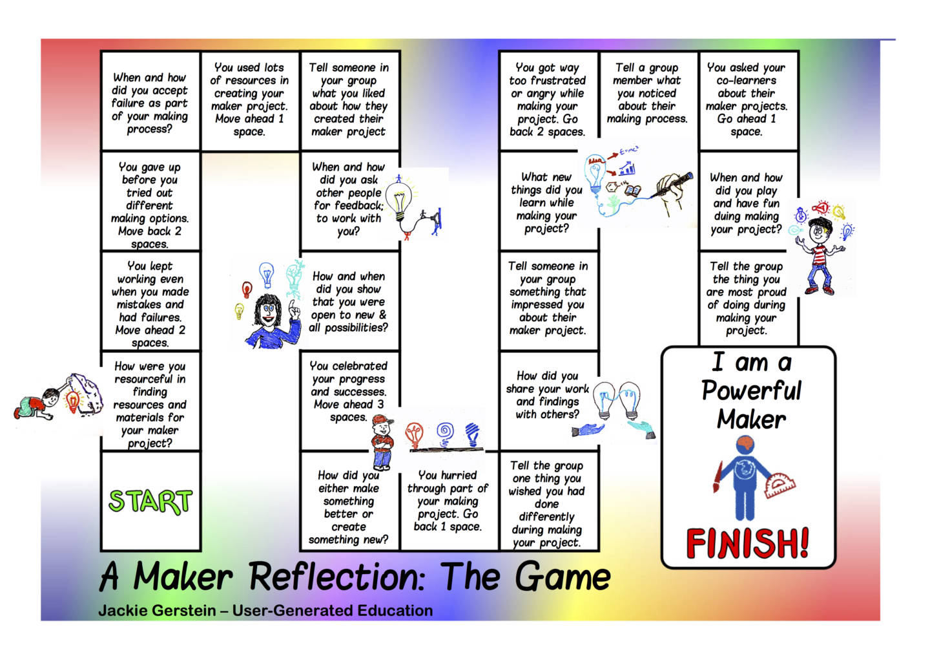A reflection board game designed to solidify learning after a maker activity. *(Courtesy Jackie Gerstein/*[*User Generated Education*](https://usergeneratededucation.wordpress.com/2015/10/05/reflecting-on-the-making-process/)*)*

“Instead of just asking questions like, ‘What was your major learning?’ or ‘How did you use the resources of your peers?’ I embedded them in the game,” Gerstein said. Student might hop two spaces forward if they can name a way they worked through a problem on their own, but slide back a few spaces if upon reflection they realize they didn’t ask friends for help before going to the teacher. Gerstein also likes to let kids get creative with reflections through video, podcasts or a blog post about their learning experiences.

“Coax them into uncomfortable ways to reflect and it might be ways they use in the future,” Gerstein said. She had a pre-service teacher who hated mind mapping before writing, but by the end of the semester she had learned to love the tool and used it before she wrote anything.

The main thing for teachers to remember is that just because they can see that students are learning doesn’t mean the students are making the same connection. And while sometimes that dynamic is good because students don’t feel like they are “in school” in the typical, boring way they are used to, it is important for students to make meaning on their own, [practice metacognition](https://ww2.kqed.org/mindshift/2016/08/10/the-role-of-metacognition-in-learning-and-achievement/" \t "_blank) and learn to self-evaluate.

“We’re missing something when we gloss over what we just did in this powerful making and not being intentional about what you learned,” Gerstein said.

Explore: [Teaching Strategies](https://ww2.kqed.org/mindshift/category/teaching-strategies/), [hands-on learning](https://ww2.kqed.org/mindshift/tag/hands-on-learning/), [maker education](https://ww2.kqed.org/mindshift/tag/maker-education/), [metacognition](https://ww2.kqed.org/mindshift/tag/metacognition/), [Project Based Learning](https://ww2.kqed.org/mindshift/tag/project-based-learning/), [reflection](https://ww2.kqed.org/mindshift/tag/reflection/), [social emotional learning](https://ww2.kqed.org/mindshift/tag/social-emotional-learning/)

[3 Comments](https://ww2.kqed.org/mindshift/2016/09/14/dont-leave-learning-up-to-chance-framing-and-reflection/#disqus_thread)

Related

[[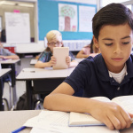](http://ww2.kqed.org/mindshift/2016/09/29/how-clear-expectations-can-inhibit-genuine-thinking-in-students/)](http://ww2.kqed.org/mindshift/2016/09/29/how-clear-expectations-can-inhibit-genuine-thinking-in-students/" \o "How Clear Expectations Can Inhibit Genuine Thinking in Students)

[How Clear Expectations Can Inhibit Genuine Thinking in Students](http://ww2.kqed.org/mindshift/2016/09/29/how-clear-expectations-can-inhibit-genuine-thinking-in-students/" \o "How Clear Expectations Can Inhibit Genuine Thinking in Students)

[[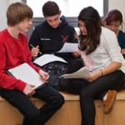](http://blogs.kqed.org/mindshift/2012/12/got-a-problem-students-can-find-the-solution/)](http://blogs.kqed.org/mindshift/2012/12/got-a-problem-students-can-find-the-solution/" \o "Got a Problem? Students Can Find the Solution)

[Got a Problem? Students Can Find the Solution](http://blogs.kqed.org/mindshift/2012/12/got-a-problem-students-can-find-the-solution/" \o "Got a Problem? Students Can Find the Solution)

[[](http://ww2.kqed.org/mindshift/2016/05/03/tinkering-spaces-how-equity-means-more-than-access/)](http://ww2.kqed.org/mindshift/2016/05/03/tinkering-spaces-how-equity-means-more-than-access/" \o "Tinkering Spaces: How Equity Means More Than Access)

[Tinkering Spaces: How Equity Means More Than Access](http://ww2.kqed.org/mindshift/2016/05/03/tinkering-spaces-how-equity-means-more-than-access/" \o "Tinkering Spaces: How Equity Means More Than Access)

[[](http://ww2.kqed.org/mindshift/2016/05/18/why-the-language-we-use-about-learning-determines-inclusivity/)](http://ww2.kqed.org/mindshift/2016/05/18/why-the-language-we-use-about-learning-determines-inclusivity/" \o "Why the Language We Use About Learning Determines Inclusivity)

[Why the Language We Use About Learning Determines Inclusivity](http://ww2.kqed.org/mindshift/2016/05/18/why-the-language-we-use-about-learning-determines-inclusivity/" \o "Why the Language We Use About Learning Determines Inclusivity)

[[](http://blogs.kqed.org/mindshift/2013/01/five-secrets-to-succeeding-without-a-college-degree/)](http://blogs.kqed.org/mindshift/2013/01/five-secrets-to-succeeding-without-a-college-degree/" \o "Five Secrets to Succeeding Without a College Degree)

[Five Secrets to Succeeding Without a College Degree](http://blogs.kqed.org/mindshift/2013/01/five-secrets-to-succeeding-without-a-college-degree/" \o "Five Secrets to Succeeding Without a College Degree)

[[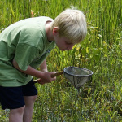](http://ww2.kqed.org/mindshift/2013/11/04/how-the-power-of-interest-drives-learning/)](http://ww2.kqed.org/mindshift/2013/11/04/how-the-power-of-interest-drives-learning/" \o "How the Power of Interest Drives Learning)

[How the Power of Interest Drives Learning](http://ww2.kqed.org/mindshift/2013/11/04/how-the-power-of-interest-drives-learning/" \o "How the Power of Interest Drives Learning)

[Powered by](https://contextly.com)

**Author**



**Katrina Schwartz**

Katrina Schwartz is a journalist based in San Francisco. She's worked at KPCC public radio in LA and has reported on air and online for KQED since 2010. She's a staff writer for KQED's education blog MindShift.

[View all posts by this author](https://ww2.kqed.org/mindshift/author/katrinaschwartz/)