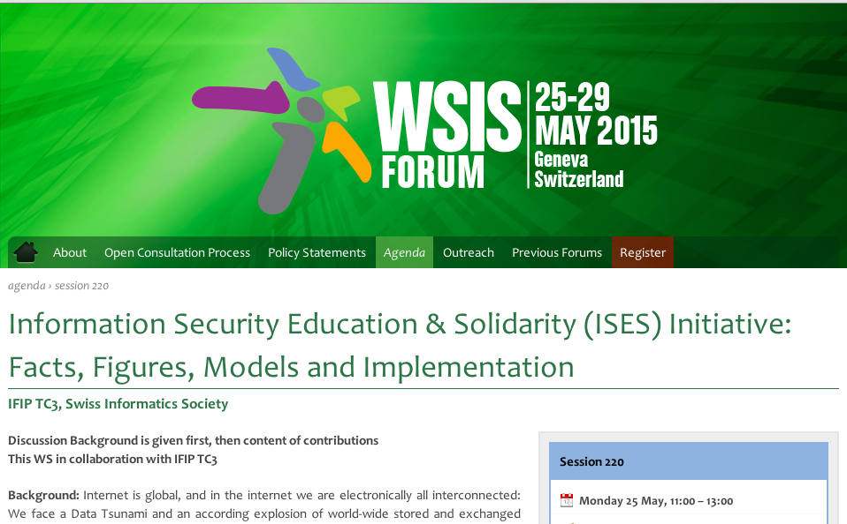

[**http://www.itu.int/net4/wsis/forum/2015/Agenda/Session/220**](http://www.itu.int/net4/wsis/forum/2015/Agenda/Session/220)

##### **Speakers / panellists**

* Prof. Dr. Bernhard M. Hämmerli, Swiss Academy of Engineering Sciences, SI and IFIP

[Introduction - Information Security Education and Solidarity (ISES) Initiative](ITU-ISES-GVA-BH-Cyber-Presentation-v2.pdf)

* Prof. Dr. Steward Kowalski, University College Gjovik Norway

[Mind the Gap - Modeling Cyber Security Governance from developing to developing nations : The continousneed for more education to fill the control gap.](http://ict-21.ch/SIC/IMG/pdf/ITU-SES-Kowalski-Mind-pa2.pdf)

* Serah Francis, ISES project, Master Student representing Kenya

[INFORMATION SECURITY AWARENESS & TRAINING PROGRAM](http://ict-21.ch/SIC/IMG/pdf/ITU%20-SES%20Serah-.pdf)

* Prof. Dr. Konrad Marfurt, Lucerne University of Applied Sciences , representing for ICT cooperation with Rwanda

[Challenges : a Case Study in Rwanda](http://ict-21.ch/SIC/IMG/pdf/ITU-ISES-Konj-Marfurt.pdf)

* Ambika Shrestha Chitrakar, PhD Student HIG, representing Nepal

[Cybersecurityin Nepal](http://ict-21.ch/SIC/IMG/pdf/ITU-ISES-Ambika-Nepal.pdf)