Feedbacks from WSIS Forum 2015 : How will act IFIP in the future to keep a role in the INFORMATION SOCIETY ?

After WSIS Forum 2015, we can observe that something is moving : the tendancy of working « in silos∗ » is beginning to be shifted to transversal activities to take in account the real needs of the Information Society

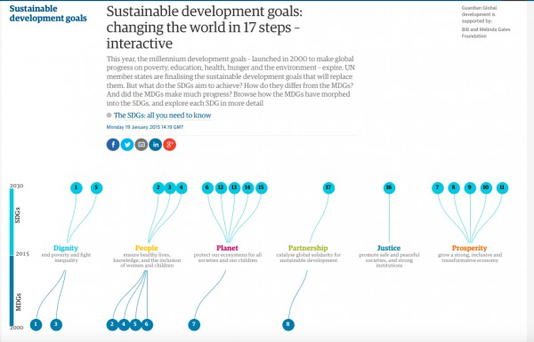

With the presentation of the matrix WSIS Action Lines – SDGs Matrix, the vision of how to work for the future is quite clear : you have to get out of « silos »

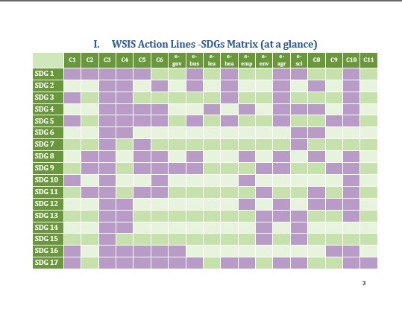

My question to the IFIP community is simple : How IFIP TCs and WGs activities will cover the above surface in the future to keep IFIP as a key player ?

I hope that we can manage during the next GA in Daejeon a slot to exchange and decide the way to act.

« Efficiency is an underproduct of lucidity »
Albert Jacquard

Some references to prepare each of us to a fruitful discussion :

- WSIS SDG (sustainable development goals) matrix document
- Sustainable development goals: all you need to know (from the Guardian)
- World Summit on the Information Society : WSIS + 10 High Level Event (9thto 13th of June 2014 at Geneva)
- ICT Indicators for Monitoring the SGDs - Overview - Susan Teltscher (ITU)
- ICT in education indicators for monitoring the SDGs : UIS's mandate within the Partnership on Mesuring ICT for Development by Peter Wallet (Unesco)
- WSIS Outcome documents - Geneva 2003 and Tunis 2005
- WSIS Forum 2015 Agenda
- WSIS Forum 2015 Policy statements Booklet (output) cf pages 201 and 202
- WSIS Forum 2015 Outcome Document (Forum tracks)
- Partnering for Success: Creativity And Professionalism In Delivering Trustworthy ICT - IFIP IP3
- from Stephen Ibaraki FCIPS, I.S.P., MVP, DF/NPA, CNP
The evolving dependence on ICTs in the Second Machine Age
- Information Security Education & Solidarity (ISES) Initiative: Facts, Figures, Models and Implementation during WSIS Forum 2015

Raymond Morel
Member of IFIP ILC (International Liaison Committee)

Contribution proposed twice as a summary of WSIS Forum 2015 for the IFIP Newsletter in June and September 2015.

∗ like WSIS action lines in the recent past, MDG to SDG, IFIP TCs before generic projects

