IFIP AI Expert Stephen Ibaraki Chairs United Nations AI Briefing
- 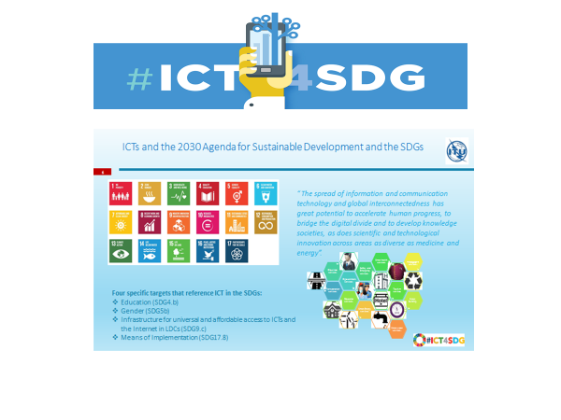

IFIP AI Expert Stephen Ibaraki Chairs United Nations AI Briefing
Stephen Ibaraki, Founding Chair of the IFIP Global Industry Council (GIC) and Vice Chair of IFIP IP3 (International Professional Practice Partnership), last week chaired and presented a keynote address at the UN Headquarters New York ITU Briefing on the “AI for Good Global Summit”.
The briefing was a resounding success by all measures with high interest by all participants including requests for follow-up. Moreover, Mr Ibaraki was requested to give a similar presentation at the World Summit on the Information Society (WSIS) to be held in June in Geneva.
Mr Ibaraki, who founded the summit along with co-organizers, ITU and XPRIZE Foundation, opened the briefing by updating attendees on the current state of play of artificial intelligence, pointing to recent developments in tracking poverty using convolutional neural networks and extending medical care through automated diagnosis well as highlighting future areas of greatest opportunity.
“The impacts of AI are going to be profound and they are happening faster than most people expect,” said Ibaraki. “Moreover, AI will power the ICTs and the 2030 agenda for sustainable development and the SDGs (Sustainable Development Goals).”
The SDG Agenda is unique in that it’s the first ‘global’ development strategy agreed to by both the developed and developing world and involved 3 years of consultations with Member States, civil society and the private sector. The SDG Agenda (Para 12) recognizes ‘connectivity’ and ‘ICTs’ as holding ‘great potential to accelerate human progress to bridge the digital divide and to develop knowledge societies’…across diverse areas’.
The specific ICT targets are:
- SDG Goal 4 – Education (clearly digital literacy and critical learning skills must go hand in hand here in order to generate relevant local content)
- SDG Goal 5 – Gender Equity (the digital gender gap is actually increasing – there are 250 million fewer women on line and the number in STEM education (especially computer science) is decreasing)
- SDG Goal 9 – Infrastructure. Target 9c calls for ‘universal and affordable access to the internet by 2020 in the least developed countries. This is an essential cornerstone to ensure that the benefits of Artificial Intelligence are to be achieved for all and to stave off some of the prevalent Orwellian scenarios that are spinning around AI.
- SDG Goal 17 – Partnerships – where ICT ‘partnerships’ (such as the ITU/UNESCO Broadband Commission, Connect 2020, WEF Internet 4 All and the AI Summit for Good) are being deployed as a ‘means of implementation’ for ALL goals and ALL targets.
ITU was at the forefront of ensuring that ICTs were recognized as a ‘cross-cutting catalyst for all three pillars of sustainable development: economic growth, social inclusion and environmental balance’.

To be held from 7-9 June 2017 in Geneva, the AI for Good Global Summit (AGGS) seeks to speed the development of, and access to, Artificial Intelligence (AI) solutions to address global challenges ranging from poverty, hunger, health and education to equality and environmental sustainability.
Organized by ITU and the XPRIZE Foundation – in partnership with UN agencies, including OHCHR, UNESCO, UNICEF, UNICRI, UNIDO, UNITAR and UN Global Pulse – the summit will evaluate the opportunities presented by AI with a view to ensuring that AI benefits all of humanity.
Mr Ibaraki is playing a foundational role as a member of the AGGS Steering Committee, founding chairman of the AGGS Outreach Committee engaging in numerous meetings, workshops and daily communications to formulate the structure, content and logistics for the event, which will bring together AI experts, stakeholders and government policymakers from around the world.
His long and active involvement not only in IFIP but also in ACM and ITU has enabled him to bring together key players and thought leaders from across the globe to enhance his personal contribution and optimise outcomes.
Thanks in part to Mr Ibaraki’s efforts, the AGGS has attached significant international attention and support. In addition to the 10+ UN bodies working to make the summit a reality, more than 50 high profile speakers have committed to participating in the program.
IFIP President, Mike Hinchey, will present at and moderate a plenary presentation at the AGGS, drawing on his extensive experience as Director of Lero, the Irish Software Research Centre and past Director of the Software Engineering Laboratory at NASA’s Goddard Space Flight Centre in Maryland. Here, his work helped make NASA missions self-managing and better able to handle challenging terrains.
Professor Hinchey, whose article entitled, “AI and Ethics – Where to Draw the Line” appeared in the March issue of the UN ITU Magazine focused on AI, will also be joined by IFIP GIC members, Frits Bussemaker and Andy Chen as plenary speakers/moderators at the Summit.
By IFIP News|April 28th, 2017

